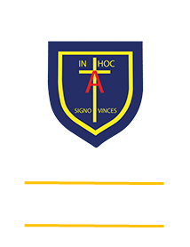
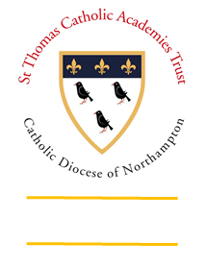
St. ANTHONY’S CATHOLIC
PRIMARY SCHOOL & NURSERY
In the Diocese of Northampton

Head Teacher: Mrs S Oppé, LLB, MA
Farnham Rd, Farnham Royal, Slough, Berkshire SL2 3AA
Tel: 01753 645828 | Email: post@stanthonys.slough.sch.uk

Learning, Growing
And Living with Jesus
“The glory of God is
a human being fully alive”

September 2020

SEPTEMBER 2021 ENTRY INTO RECEPTION CLASS

Dear Parent/Carer of nursery children

Just as the children are settling into nursery, it is now time to start thinking about applying for school next September.

The online site opened on 1st September and ALL forms must be completed by midnight on 15th January 2021. Any forms received after this date by Slough Council will be processed as late applications this could affect your choice of school.

Please log into www.slough.gov.uk website and complete your application, you will need to create a Slough citizens portal log in to apply.

All parents must complete an application form online with the local authority for your child as a nursery place does not guarantee a place in reception next year.

If you have any queries please call Mrs Dhami in the office.

Yours faithfully

Mrs S Oppé
Head Teacher

