Week beginning 4th May 2020 St Anthony’s Year One weekly timetable of work
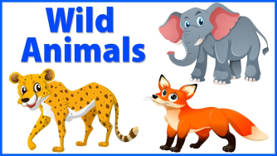Topic: Wild Animals and Habitats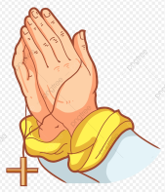
Please log into Purple Mash and complete the 2Do tasks on there as well. Send them back to us so we can see what lovely work you have been doing. I wonder how many rewards you can earn on it as there’s lots to achieve. Below are all of the rewards you can earn. Try and earn them all!
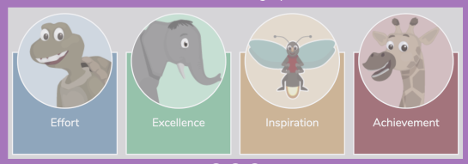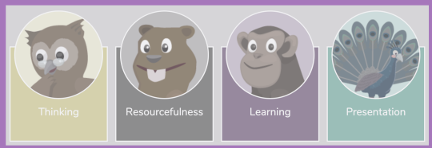
Try and complete the maths and literacy activities in the morning and leave the RE, Science and Creative for the afternoon.
MONDAY | TUESDAY | WEDNESDAY | THURSDAY | FRIDAY
May is a special month when we particularly think of Mary.
Hail Mary full of grace, the Lord is with thee.
Blessed art thou amongst women, and blessed is the fruit of thy womb, Jesus.
Holy Mary, Mother of God, pray for us sinners now, and at the hour of our death.
10 mins of exercise each day - either Joe Wicks or do 10 star jumps 10 stretches to the ceiling, 10 stretches to touch the floor with your hands flat on the table, 10 hops on either leg
10 mins of reading each day – you can read a story you have got in your school bag, books you may have from the library or books you have at home. You are able to read parts of a story yourself now so please make sure you put time aside each day to do this. If you need an adult to help you with reading, find a time when they are available to help you. If you have an older sibling in your house, maybe they can sit and read with you too.
Maths  Writing number words to 20  Let’s warm up our bodies and our Maths brains at the same time by counting to 100 with Spiderman  https://www.youtube.com/watch?v=L9md4L2pAVQ  We are going to practise writing number words to twenty. E.g. one, two, three...  Can you write some number words with?  - Chalk outside?  - a paintbrush and water on an outside surface?  Challenge  Use this link to generate numbers at random.  Can you spell that number?  https://www.roomrecess.com/Tools/RandomNumberPicker/go.html  You can set your own number limit. How high can you go? | Maths  Finding 1 more and 1 less  Use this link to open the splat number square.  https://www.primarygames.co.uk/pg2/splat/splatsq100.html  Choose a colour and then select any number.  Highlight the number that is one more and one less. For example, if you chose 32, 33 would be one more and 31 would be one less.  Remember that if you’re finding one more than a tens number (10,20,30,40...) you need to go down to the beginning of the next row.  You could practise writing the number sentence too e.g. 30 + 1 = 31, 30 – 1 = 29  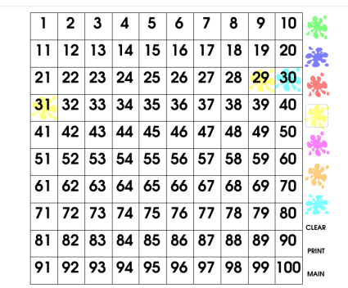  Challenge:  Look away from the number square. Practise finding one more/less without looking, then check if you’re right.  For an extra challenge see if you can find two more/less without looking. | Maths  Finding 10 more and 10 less  We’re using the splat number square again today.  https://www.primarygames.co.uk/pg2/splat/splatsq100.html  Start off by counting in 10s on the number square.  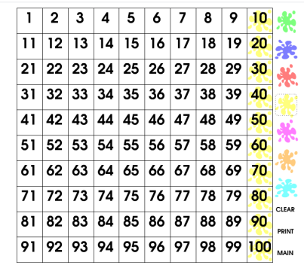  Practise finding 10 more and 10 less than the tens numbers  When we find ten more, we go down to the next row. For ten less we go up to the row before. Ten less than 40 is 30, ten more than 40 is 50.  Choose any number on the number square now. In the same way (going down for ten more, up for less) practise finding ten more and ten less than any number.  Write some of your number sentences down e.g. 23 + 10 =33  Challenge:  Can you find twenty more/less than any number?  What is the same/different than finding ten more/less. | Maths  Place Value  Tens and ones  https://www.primarygames.co.uk/pg2/splat/splatsq100.html  Using the splat square choose any column and highlight all of the numbers in that column.  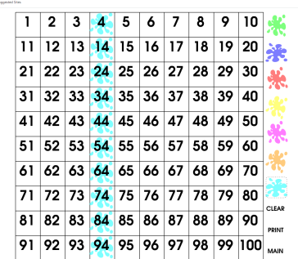  On a piece of paper make two columns like this:  The number 23 has two tens in it – you can count in 10’s to check: 10,20.  It also has three ones. Count on 3 starting from 20; 21,22,23  On your piece of paper write down the numbers from the column you chose on the splat square. Highlight the tens and ones in different colours.  What pattern do you notice?  Repeat with different columns.  Challenge:  After the number 99 we need to add another column.  Choose a number above 99 e.g. 102 and see if you can count in tens from there.  You can see from the example above that I started from 102 and then added 10.  What changes? What stays the same? | Maths  Place Value  Have a go at this game and see if you can save your boat from being attacked from the shark.  Count the dienes  The red dienes are ones. The yellows are tens and if you feel like a challenge the greens are hundreds.  https://www.ictgames.com/sharkNumbers/mobile/index.html
  Tens | Ones
  Tens | Ones
  0  1  2  3  4 | 4  4  4  4  4
  Hundreds | Tens | Ones
  1  1 | 0  1 | 2  2
Keeping Active!
We now have free access to online PE lessons and games. Use this website to log on. There’s lots of fun activities for each week on here.
The website is: https://home.jasmineactive.com/
Username: parent@stanthonys-2.com
Password: stanthonys
Literacy  Learn a new story  This week we will be learning about the story ‘Dear Zoo’. Watch the story and learn about it from YouTube. Here is the link for it:  https://www.youtube.com/watch?v=XoA-3e1Jb10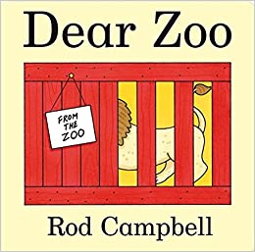  Challenge: Can you retell the story to someone in your house? | Literacy  Create puppets from this story  Can you draw some of your favourite characters from the story, colour them in and cut them out. Can you use straws on the back to create stick puppets? If not, you can use rolled up newspapers as sticks. Have fun and be creative!  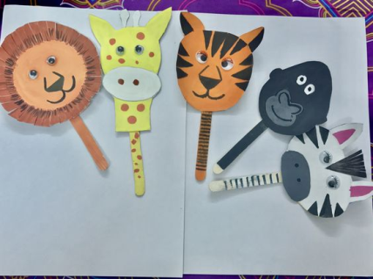  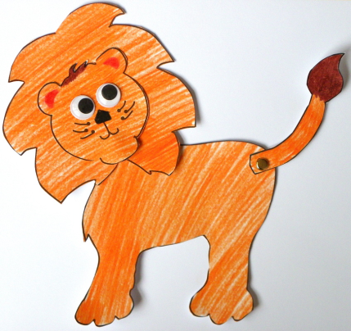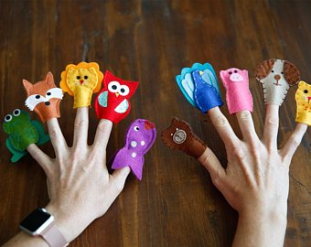 | Literacy  Spelling practise  Can you practise your spellings of the wild animals we are learning about? Try and see how many of them you can get correct:  - Lion  - Tiger  - Giraffe  - Hippo  - Zebra  - Elephant  - Camel  - Snake  - Monkey  - Bear  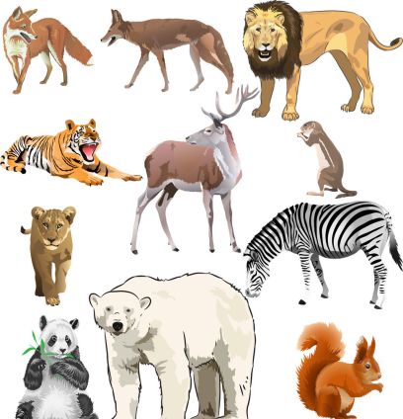  Challenge spellings:  - Antelope  - Gorilla  - Panda  - Ostrich  - Koala bear | Literacy  Describe animals using adjectives  Let’s try and use some adjectives to describe the animals.  What words can you think of to describe the following animals:  - Lion  - Zebra  - Elephant  - Giraffe  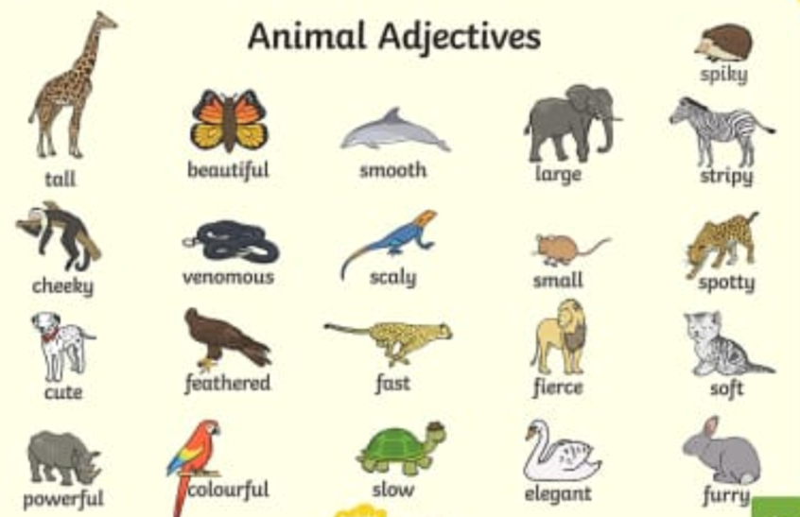  Challenge:  Can you describe 2 more animals of your own choice using DIFFERENT adjectives? | Literacy  Writing fantastic sentences  Today we can try and write some sentences using the adjectives you learnt yesterday.  How many fantastic sentences can you write about the animals? Don’t forget to use a capital letter, finger spaces and a full stop in your work.  For example:  The fantastic lion has got soft fur on him.  The stripy zebra has got two long and pointy ears.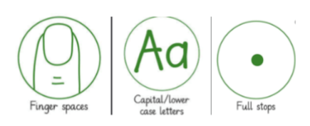  Challenge: Can you use the connective ‘and’ in your sentences to make them even better?  
RE  Ascension Day  Do you know what the word ascend means?  It means to go up.  We go up the stairs.  We go up in a lift.  We go up a hill.  Can you think of any other things we ascend?  Read this story from the bible (John 13:33; 14:18.)  or watch it on the link below.  While you are reading/watching think about these questions:  Where did Jesus go up to?  Who did He promise to send?  How did the disciples feel after Jesus had left?  How did they feel when the Holy Spirit came?  John 13:33; 14:18.  https://www.youtube.com/watch?v=UcFw8pLBSIo  Remember that the Holy Spirit is still with us today.  Say a prayer to thank God for sending his Holy Spirit to help us.  How would you like Him to help you today? | Science  Go on a minibeast hunt and see how many of the following creatures you can find. You can draw them on a piece of paper or simply write the names of the creatures you need to find... good luck!  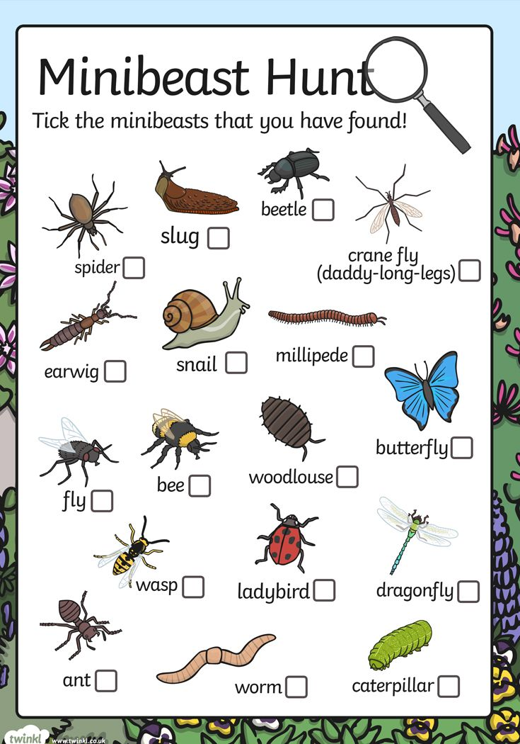 |  | Creative  Follow these step by step guides to learn how to draw some animals. Don’t forget to send us pictures of your lovely work if you would like to. Our email addresses are below.  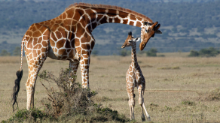How to draw a giraffe:  https://www.youtube.com/watch?v=oRNpohX5pjc  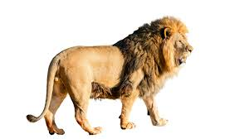How to draw a lion:  https://www.youtube.com/watch?v=B1lIijlOqwI  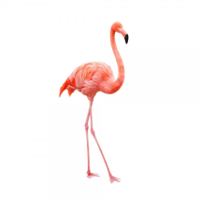How to draw a range of animals such as fishes, elephants, bees, octopus’, owls, penguins, caterpillars, ladybirds, dogs and even flamingos!  https://www.youtube.com/watch?v=7SWvlUd2at8
History
VE DAY – We are celebrating the formal acceptance by the Allies of World War II of Nazi Germany's unconditional surrender of its armed forces on 8 May 1945.
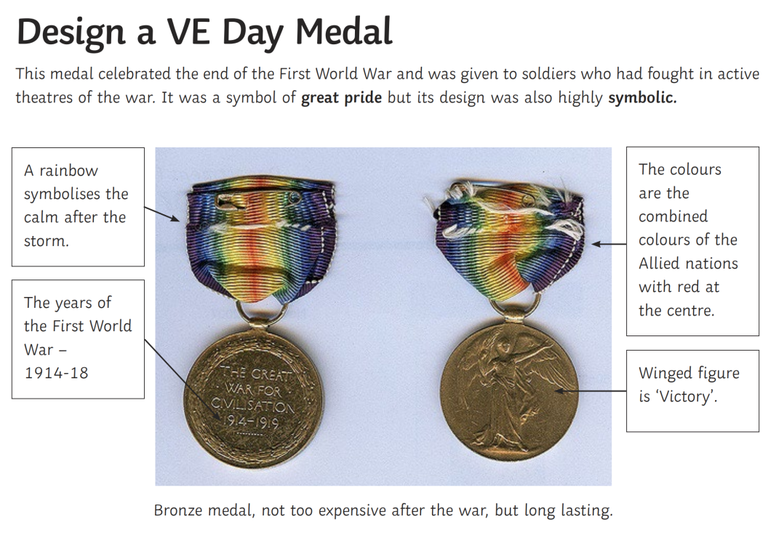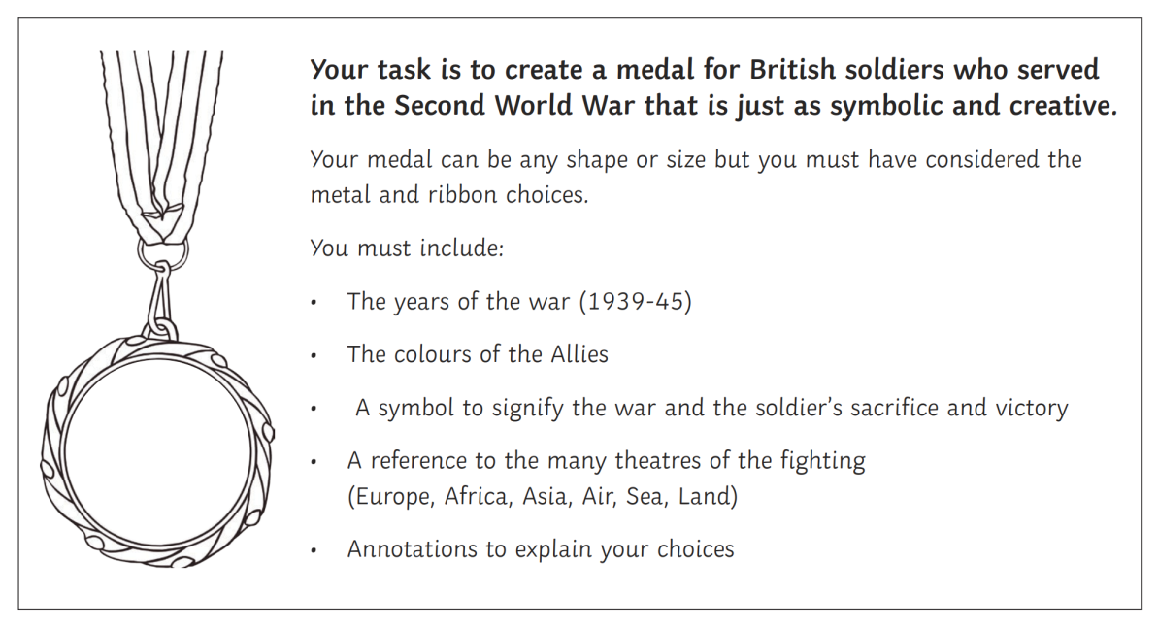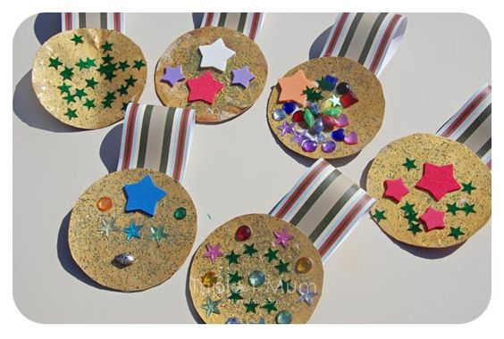
Design your own Union Jack flag.
You can draw these lines onto your own paper at home and then add a stick on it. Make sure you use the correct colours.
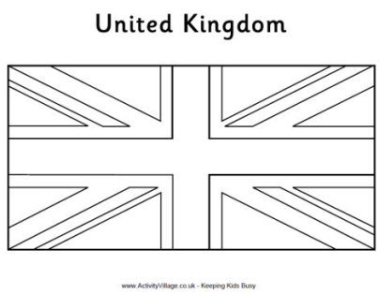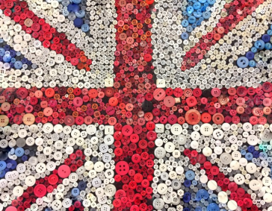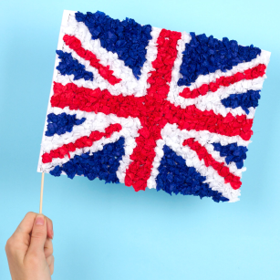
Contact details
If you would like to send pictures of work back to us/ have any queries, please contact us via email. Please email us ONE email with all your child’s work for this week otherwise we will be getting a lot of separate emails from parents. It’s ok if you don’t email the work until Friday so we receive it altogether as one message.
Mrs Chavda (1 Joshua) achavda@stanthonys.slough.sch.uk
Miss McBrearty (1 Ruth) hmcbrearty@stanthonys.slough.sch.uk

