**Year 4**

**Maths**

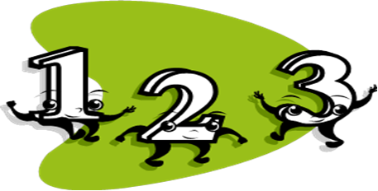

Fun ideas to help your child with maths

**By the end of Year 4, most children should be able to…**

Know all the times tables by heart up to 12 x 12, e.g. know facts like 7 x 5= and division facts like 36 ÷ 4=.

Round numbers like 672 to the nearest 10 or 100.

Work out that a simple fraction like 2/6 is equivalent to 1/3.

Work out sums like 26 + 58 and 62 – 37 in their heads.

Work out sums like 234 + 479 or 791 – 223 using pencil and paper and writing them in columns.

Multiply numbers like 38 by 10 or by 100, and divide numbers like 4200 by 10 or by 100.

Multiply and divide numbers up to 100 by 2, 3, 4 or 5, and find remainders, e.g. 36 x 3, 87 ÷ 4.

Change pounds to pence and centimetres to metres, and vice versa, e.g. work out that £3.45 is the same as 345p, and that 3.5 metres is the same as 350 centimetres.

Tell the time to the nearest minute and use a simple timetable.

Pick out shapes with similar features, e.g. shapes with sides the same length, or with right angles, or symmetrical shapes.

Use +, –, x, ÷ to solve problems and decide whether it is best to calculate in their head or on paper.



To answer world problems and identify the calculation needed.

To present data in a range of forms. Bar charts, tally charts and line graphs.

**Fun activities to do at home**

**Number game 1**

You need about 20 counters or coins.

♦ Take turns. Roll two dice to make a two-digit number, e.g. if you roll a 4 and 1, this could be 41 or 14.

♦ Add these two numbers in your head. If you are right, you win a counter. Tell your partner how you worked out the sum.

♦ The first to get 10 counters wins.

Now try subtracting the smaller number from the larger one.

**Number game 2**

♦ Put some dominoes face down.

♦ Shuffle them.

♦ Each choose a domino.

♦ Multiply the two numbers on your domino.

♦ Whoever has the biggest answer keeps the two dominoes.

♦ The winner is the person with the most dominoes when they have all been used.

**Number game 3**

Use three dice. If you have only one dice, roll it 3 times.

♦ Make three-digit numbers, e.g. if you roll 2, 4

and 6, you could make 246, 264, 426, 462, 624 and 642.

♦ Ask your child to round the three-digit number to the nearest multiple of 10. Check whether it is correct, e.g.

76 to the nearest multiple of 10 is 80.

134 to the nearest multiple of 10 is 130. (A number ending in a **5** always **rounds up**.)

♦ Roll again. This time round three-digit numbers to the nearest 100.

**Tables**

Practise times tables. Say them forwards and backwards. Ask your child questions like:

What are five threes? What is 15 divided by 5?

Seven times three? How many threes in 21?

**Measuring**



Use a tape measure that shows centimetres.

♦ Take turns measuring lengths of different objects, e.g. the length of a sofa, the width of a table, the length of the bath, the height of a door.

♦ Record the measurement in centimetres, or metres and centimetres if it is more than a metre, e.g. if the bath is 165 cm long, you could say it is 1m 65cm (or 1.65m).

♦ Write all the measurements in order.

**Looking around**

Choose a room at home. Challenge your child to spot 20 right angles in it.



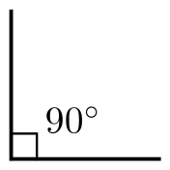

**Dicey division**

You each need a piece of paper. Each of you should choose five numbers from the list below and write them on your paper.

5 6 8 9 12 15 20 30 40 50

♦ Take turns to roll a dice. If the number you roll divides exactly into one of your numbers, then cross it out, e.g. you roll a 4, it goes into

8, cross out 8.

♦ If you roll a 1, miss that go. If you roll a 6 have an extra go.

♦ The first to cross out all five of their numbers wins.

**Sum it up**

♦ Each player needs a dice.

♦ Say: *Go!* Then each rolls a dice at the same time.

♦ Add up all the numbers showing on your own dice, at the sides as well as at the top.

♦ Whoever has the highest total scores 1 point.

♦ The first to get 10 points wins.

**Out and about**

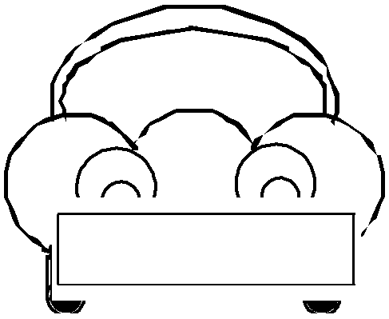

♦ Choose a three-digit car number, e.g. 569.

♦ Make a subtraction from this, e.g. 56 – 9.

♦ Work it out in your head. Say the answer.

♦ If you are right, score a point.

♦ The first to get 10 points wins. **H569 TPK**

**Dicey tens**

For this game you need a 1–100 square (a snakes and ladders board will do), 20 counters or coins, and a dice.

♦ Take turns.

♦ Choose a two-digit number on the board e.g. 24.

♦ Roll the dice. If you roll a 6, miss that turn.

♦ Multiply the dice number by 10, e.g. if you roll a 4, it becomes 40.

♦ Either add or subtract this number to or from your two-digit number on the board, e.g. 24 + 40 = 64.

♦ If you are right, put a coin on the answer.

♦ The first to get 10 coins on the board wins.

**Pairs to 100**

This is a game for two players.

♦ Each draw 10 circles. Write a different two-digit number in each circle – but not a ‘tens’ number (10, 20, 30, 40…).

♦ In turn, choose one of the other player’s numbers.

♦ The other player must then say what to add to that number to make 100, e.g. choose 64, add 36.

♦ If the other player is right, she crosses out the chosen number.

♦ The first to cross out 6 numbers wins.

**Mugs**

You need a 1 litre measuring jug and a selection of different mugs, cups or beakers.

♦ Ask your child to fill a mug with water.

♦ Pour the water carefully into the jug.

♦ Read the measurement to the nearest 10 millilitres.

♦ Write the measurement on a piece of paper.

♦ Do this for each mug or cup.

♦ Now ask your child to write all the measurements in order.

**Shape hotline**

♦ Think of a 3d shape.

♦ Pretend to call you partner on the shape hotline. Explain the properties of your shape.

Partner 1: *Hello shape hotline how may I help?*

Partner 2: *I have a shape but I don’t know what it is.*

Partner 1: *Please can you describe its properties?*

Partner 2: *It has 6 faces, 12 edges and 8* vertices.

Partner 1: *I’ve got it you have a cube!*

♦ Go through 5 shapes each. The one to guess the most shapes correctly wins.

**C:\Users\cleach\AppData\Local\Microsoft\Windows\Temporary Internet Files\Content.IE5\LFFWD9VM\MC900048411[1].wmf**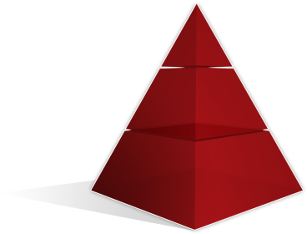C:\Users\cleach\AppData\Local\Microsoft\Windows\Temporary Internet Files\Content.IE5\IG1IEFJV\MC900048285[1].wmfC:\Users\cleach\AppData\Local\Microsoft\Windows\Temporary Internet Files\Content.IE5\LFFWD9VM\MC900048283[1].wmf