HISTORY  Create a timeline of at least eight natural disasters that have occurred around the world and give a brief description of each.   | ART  Create a rainbow using any materials you like. Remember the colour order of a rainbow is ROYGBIV. Get creative!  Be sure to take a picture of your unique work and send it on to us.   | RE  Create your own crossword puzzle (use a ruler) using these twelve words relating to pentecost:  Heaven, spirit, wind, sound, Pentecost, fill, fire, language, house, holy, speak, amazed  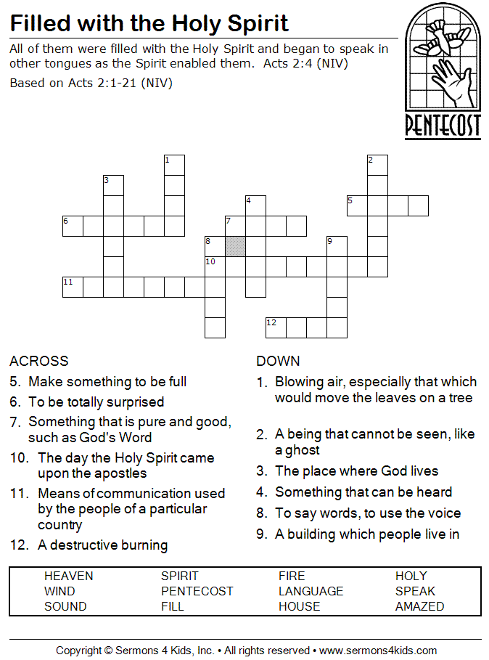  Be sure to use a dictionary to help you write your clues for each of the words. 6 down and 6 across. | LITERACY  Write a newspaper article relating to one of the natural disasters that you added to your timeline. Include a headline, description of event and a drawing or photo. In your description of the event, please answer the 5 Ws (who, what, where, when and why) in separate paragraphs.  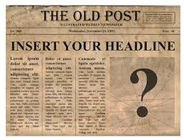
MATHS  After completing your outdoor activity scavenger hunt, make a bar chart showing how many of each item you were able to find. Don’t forget to use a ruler and present it well!  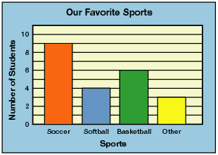 | SCIENCE  Choose two animals – one herbivore and one omnivore.  Write a comparison describing the similarities and differences between their teeth. Why do you think they are the same or different? | GEOGRAPHY  On a map, locate each of the countries where a natural disaster occurred (from your history timeline). For example, if one of the natural disasters you in your timeline was Hurricane Katrina, you would locate New Orleans on a map. | Outdoor Activity  On your daily walk, record how many of each of these you can spot. Afterward, you will be able to complete the maths activity.  Dog  Shop  Bird  Bike

