MATHS  Percentages  550, 860, 1200, 1540, 1720  Find 10%  25%  50%  and 75%   | MATHS  Here is a times table grid. Have a go at learning the 6 times table. Try to know them off by heart by the end  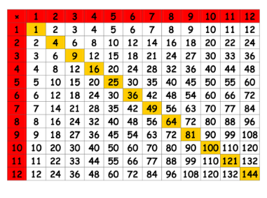  Of the week. Get an adult or older sibling to test you. | MATHS  Can you solve these worded maths problems?  Stephan starts his walk to school at 7.35. He arrives at school at 8.10 How long does his walk take?  Claire’s book has 656 pages. She reads 64 page Monday, 87 pages Tuesday, 45 pages Wednesday and 121 pages on Thursday. How many pages does she have left?  Rebecca wants to raise money for the nhs. Her target is £3600. So far she’s raised £1440. What percentage is this?  Challenge  Make up your own 2 step word problem and challenge someone at home. | ENGLISH  How many words can you make from the anagram wheel? All 9 letters can be used to make a word.  Can you try and make a nine-letter word from it?  G  H  I  O  S  Your text here  N  T  M  E
  ENGLISH  Add punctuation and correct the misspelt words to make these sentences correct  1-it was a beutfol day so chris decided to walk his dog  2-miss Crosbie and Mrs hepden work in 5luke  3-Do you what to go to the park today asked mum!  4-how much sides does a Pentagon have?  5-Patricia loves art music history and science  6-Im so exsited that the sumer hollidays are nearly here. | ENGLISH  I’m sure many of you have been missing you friends and teachers during lockdown.  Write a letter to one of them about the things you’re are looking forward to once things are back to normal.  Make sure you ask them questions about how they are and what they are looking forward to.  Watch an episode of Book Club on CBBC each day on the TV or on i-Player | MUSIC  Write a song about life over the last 10 weeks. What have you been doing? How has life changed? How have you been feeling? | HISTORY  Last week Elon Musk sent a rocket into space. There have been many previous missions into space the most famous being in 1969.  Can you research that famous mission?  What was it called?  Where was it to?  What were the astronaut’s names?  How many other facts about that mission can you find?  Draw a picture to go with your research.  Watch Horrible Histories on CBBC each day on the TV or on i-Player
SPELLINGS  Choose the correct prefix to make a new word:  mis de im un dis  lead do  code belief  equal possible  proper interpret  place clear  connect activate | SCIENCE  Harry Potter Potions!  For all you muggles who wants to be wizards.  Imagination soup has lots of experiments you can do by renaming the items in your kitchen cupboards as magical ingredients.  Make sure you ask an adult to help you. List your ingredients, name your potion and tell us what it does.  Have fun!!!  Watch Operation Ouch on CBBC each day on the TV or on i-Player | WELLBEING  Every year we celebrate St.Anthony’s day together with mass followed by music, fun and games and finishing with a picnic.  Even though this year we can’t all be together please try to celebrate with your families and home in similar ways to how we would at school.  Start the day with a prayer together followed by playing some games. After that have a sing and dance in your garden and finish off with a picnic. Maybe you could make some decorations! Take photos for memories | RE  This week we will be celebrating St.Anthony’s day.  Do some research into St.Anthony including what his life was like before and after his calling to become one of Christ’s followers.  What do you think inspired him to follow Christ?  Why do you think he is the patron Saint of lost things?
https://worldoceanday.school/ - join in the action on Monday. The events are listed on FaceBook.

