Solo Stems for Learner Responses
 | Bronze | Silver | Gold | Platinum
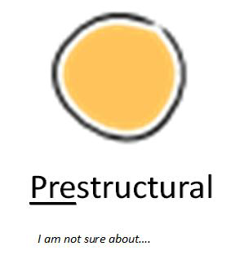 | 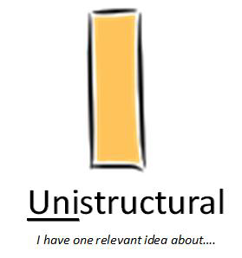 | 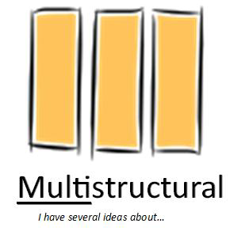 | 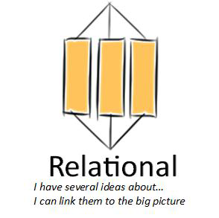 | 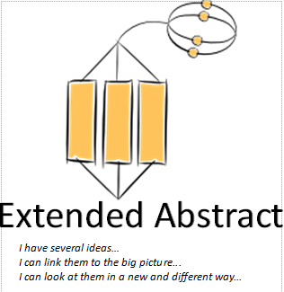
Seeking clarification  Work shows lack of understanding of the key concepts covered in the lesson | Building ideas  At the unistructural level feedback will be mostly functional to address basic errors in understanding however you also need to begin to help them make links between the ideas | Adding, combining and evidencing  Their functional knowledge should be increasingly secure and they should now be thinking about using and applying their ideas | Identifying cause and effect, contrast and similarities and sequencing  With secure functional knowledge pupils should be able to explain and rationalise their thinking and increasingly be able justify their answers | Commenting, concluding, identifying anomalies and exceptions, forecasting and predicting, hypothesising  At this level they should be using and applying their knowledge in an ever-widening context – with a fully developed rationale
Answer stems will be factual based on single ideas and drawing on the direct content taught | Answer stems will be factual based on at least two different pieces of information and drawing on the content of the lesson including their own discussions and reading | Answer stems will begin to draw ideas together and make some key links between the ideas. Connectives and subclauses will add detail.  Ideas will come for the taught content, individual research and group and paired discussions | Answer stems will require learners to explain and justify their answers drawing on evidence in the lesson including their own reading and research, group discussions and prior learning | Answer stems will require learners to express their own ideas and opinions drawing on prior learning and other subjects as well as the lesson content. They will be expected to speculate, hypothesise and generalise
I can see this in …  I think …….  This is an example of …  This is similar to ……  I like / don’t like……….  I prefer  My idea …  It is similar to …  I found out by ….  The key idea is ….  The main reason ….  The most important piece of information is ….. | I have found out that ..  I already knew ….  This relates to something I have learnt before in  There are xx examples  I think it is unusual / interesting/ different/ surprising because  The reason this happened is  My evidence is  First you need to … then …  The following points are the most important … | This links to (my previous work, work in) …  These ideas link together because …  The factors we need to consider are ….  The next step is to ….  I could improve it by …  I can combine these ideas to …..  Another example is ….  The evidence I have is … (multiple examples)  I agree that / with ….  The similarities / differences between these are ….  I need to do xx first and then …..  The correct sequence is …  I have learnt / discovered that …  I could improve this by …. | This was caused by  It happened because  The evidence I have to explain why is ….  This made a difference because ….  If you change xx this will/may happen ….  An alternative way of (doing/looking) at this is ….  This happened before / after  This happened because  Comparing these ideas, I think ….  This (system, process) would be best because …  If I was writing instructions for someone else I would say ….  The most important features / aspects you need to consider / remember are ….  This relates to other things I have learnt in …  This might effect (people/ countries/ systems) by / because ….. | To summarise the key points….  The most important points to consider are  My view of …. Is and I think that because  My conclusions are ….. because  This always true because …  The exceptions to this are ..  I can generate a rule for the use of ….. because …  The consequences of …… are …  I think xx will happen to ….. because  The implication/s of this would be ….  My solution would be …. because …..  The arguments for and against are …..  An alternative solution might be to ….  This fit into what we know about ….. because ….  If xx happened I think it would lead to …  There examples of this in the world today in ….  We can use this knowledge in our everyday lives to  This knowledge will be important to (us, scientists, politicians etc) because …

