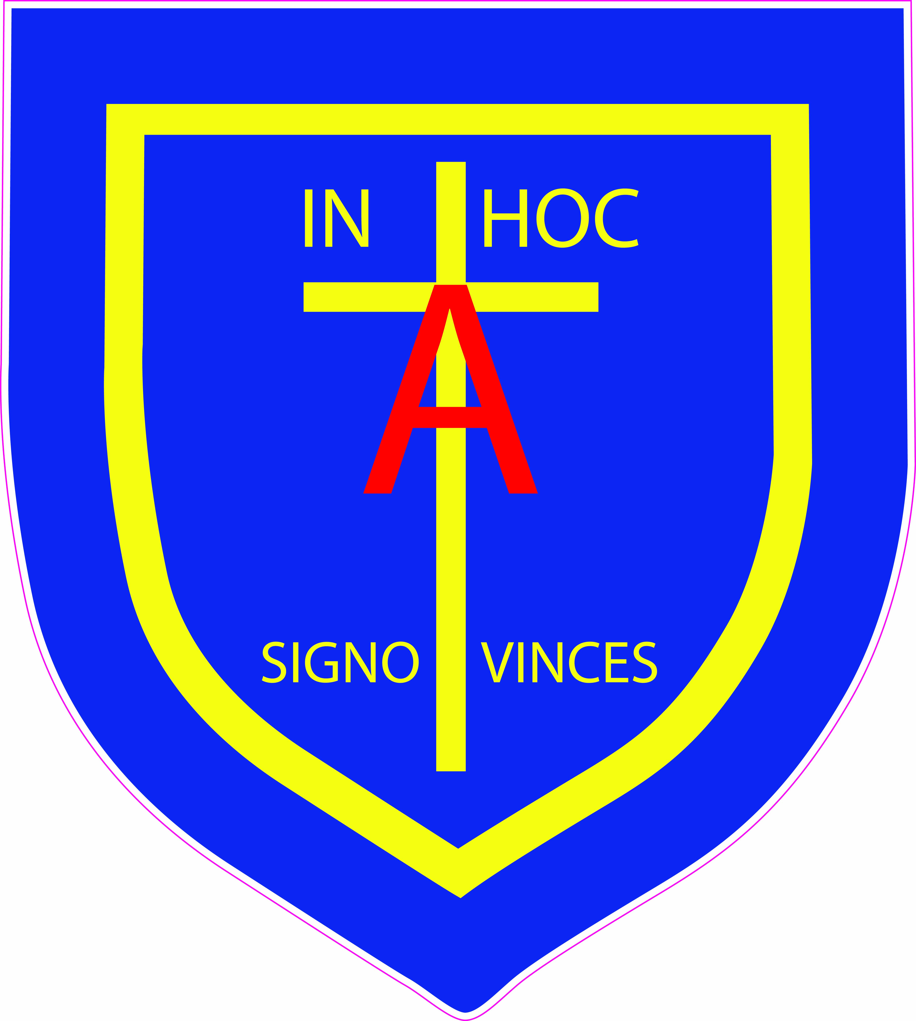

St. Anthony’s Catholic Primary School & Nursery
Diocese of Northampton
St Peter Catholic Academy Trust
Farnham Rd, Farnham Royal, Slough, Berkshire SL2 3AA
Tel: 01753 645828 Fax: 01753 645011 Email: post@stanthonys.slough.sch.uk
Interim Head Teacher: Mrs S. Oppé, LL.b, PGCE, MA, NPQH
Learning, Growing and Living with Jesus
Sports Coach/ Teacher
Full Time: Hours to be agreed
Salary: Dependant on experience

Our gold standard UNICEF Rights Respecting, caring and creative school is delighted to offer this new role within our happy and hardworking team with well-behaved and valued children. Set in delightful grounds on the easily accessible outskirts of Slough, we are seeking to appoint enthusiastic and innovative Sports Coach. This is a an ideal position for an experienced Sports Coach or Sports graduates or NQTs with multi sports skills wanting to get experience in a school setting.

We are looking for an enthusiastic and proactive sports coach to provide an exciting and stimulating sport curriculum as well as lead extra-curricular activities and develop participation in local competitions and sports events. You will take responsibility for the majority of lessons planned and taught, and provide professional development for teachers in delivering their own lessons. This will be a flexible role working with children from Nursery up to Year 6 and needs someone with a good understanding of child development.

Hours: To be discussed but will accommodate delivering lessons during the school day and after school clubs finishing by 4.30pm. This is a term time role only with additional attendance at one week of inset days during the year. We hope that the coach will take a lead on providing enrichment and games during the lunchtime to contribute towards overall sports provision and our healthy school ethos.

Our school is committed to enhancing the learning of all and to promoting the safety and well-being of children and adults. An enhanced DBS will be required.

You are warmly invited to come and visit, talk with the staff and meet the children. We would welcome the chance to show you around our vibrant school where all are equally important. If you would like to arrange a time please contact Mrs Sam MacKenzie, the School Business Manager on bursar@stanthonys.slough.sch.uk
The application form and further details can be found on our website http://www.stanthonys.slough.sch.uk under News/Vacancies.
Closing Date: 18/12/21 Interviews: on application

