Long Term Plan: Reading 2021 - 2022
Year
Term | Advent |  | Lent |  | Pentecost
Class guided book | The Minpins  Roald Dahl  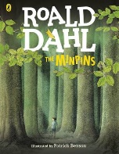 | Leo and Gogon’s Curse  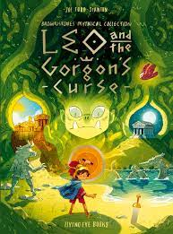 | The Iron Man  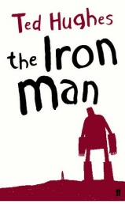 | Window: 1 | Mousehole Cat  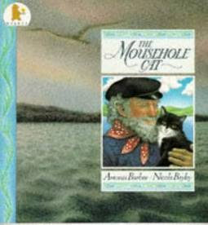 | The Lion the Witch and the Wardrobe  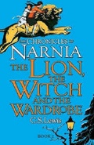
Poetry |  |  | Mid-term break  Seamus Heaney
Video Clip  for comprehension | David Guetta - Titanium |  | Sometimes The Stars by The Audreys
Picture books
Daily class reader for pleasure | So you think you’ve got it bad? Life in ancient Greece  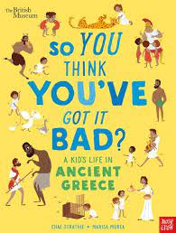 | The night before Christmas  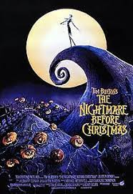 | Bear Grylls  