Long Term Plan: Reading 2022-2023
Year 5
Term | Advent |  | Lent |  | Pentecost
Class guided book | Mufaro’s Beautiful Daughters  John Steptoe  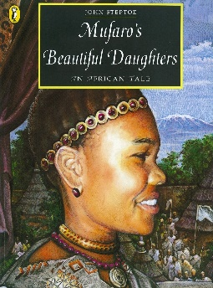 | Boy at the Back of the class  Onjali Q’Rauf  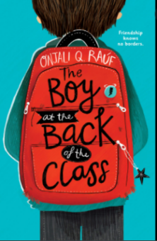 | Viking Boy  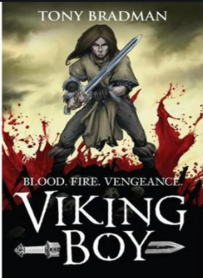  Tony Bradman | Treason  Berlie Doherty  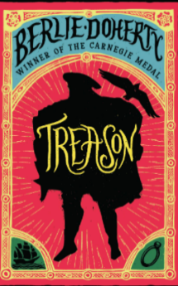 | Wonder  RJ Palacio  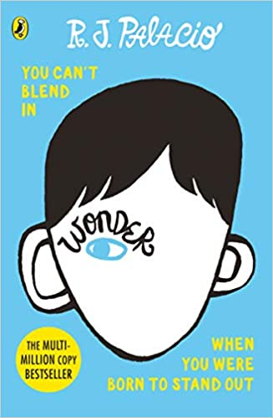 | Domovoy  Joanna Hardej  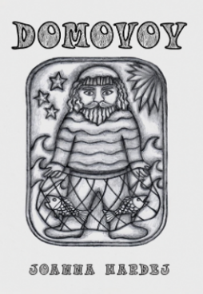
Poetry | TBC |  | TBC |  | TBC
Video Clip  for comprehension | https://www.youtube.com/watch?v=pXPV35dah8I
Picture books | Mufaro’s Beautiful Daughters  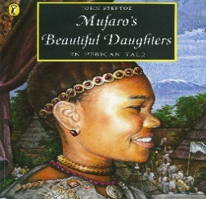  John Steptoe |  | Wisp  Zara Fraillon and Grahame Baker-Smilh  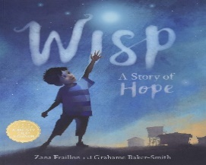
Daily class reader for pleasure | Boy at the Back of the class  Onjali Q’Rauf  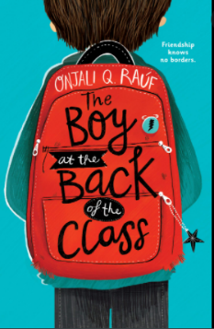 |  | Cosmic it’s one giant leap for boy-kind  Frank Cottrell-Boyce  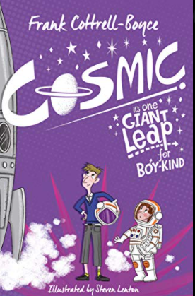 |  | The Nowhere Emporium  Ross McKenzie  