**St. ANTHONY’S CATHOLIC**

**PRIMARY SCHOOL & NURSERY**

In the Diocese of Northampton

Head Teacher: Mrs S Oppé, LLB, MA

Farnham Rd, Farnham Royal, Slough, Berkshire SL2 3AA

Tel: 01753 645828 | Email: [post@stanthonys.slough.sch.uk](mailto:post@stanthonys.slough.sch.uk)

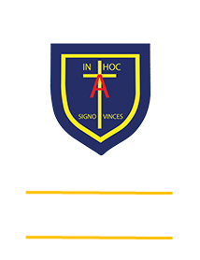

Learning, Growing

And Living with Jesus

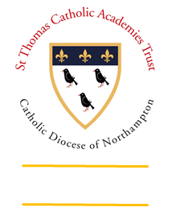

“The glory of God is

a human being fully alive”

**PERFORMANCE OVERVIEW 2020/21 - KEY STAGE 2 2020/21**

|  |  |  |  |  |  |  |
| --- | --- | --- | --- | --- | --- | --- |
|  | Reading | Writing | Maths | GPS  (Grammar Punctuation and Spelling) | Combined | RE |
| Expected | 66% | 70% | 75% | 76% | 61% | 70% |
| Greater Depth | 25% | 6% | 28% | 33% | 6% | 17% |